6.35: a) The static friction force would need to be equal in magnitude to the spring force, 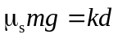 or 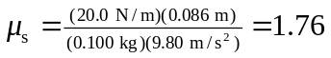, which is quite large. (Keeping extra figures in the intermediate calculation for d gives a different answer.) b) In Example 6.6, the relation
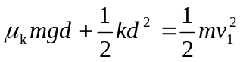

was obtained, and d was found in terms of the known initial speed 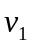. In this case, the condition on d is that the static friction force at maximum extension just balances the spring force, or 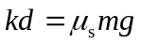. Solving for 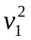 and substituting,
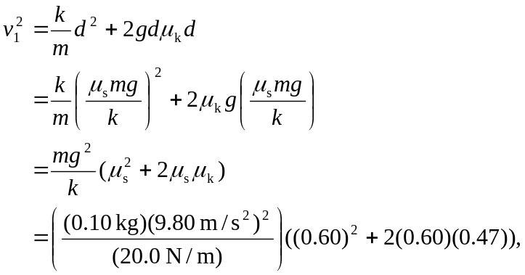
from which 

